**Junior Teacher**

**Former Junior MERN Stack Teacher & Instructor at Dhoraji IT Skill Development**

**2016**

+92 3310334392

**EXPERIENCE**

**EDUCATION**

**CONTACT**

**Skills & Abilities**

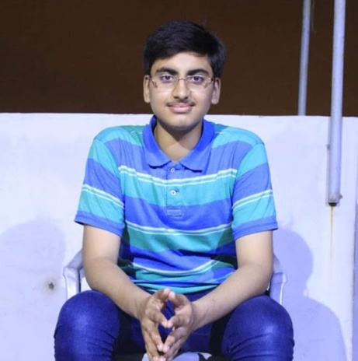

**Ahmed Raza**

**HTML, CSS**

**JavaScript**

**Firebase & Firestore**

**React & React Native**

**Node.js & MongoDB**

**MS Office**

**Civic Secondary School**

**2010-2017**

**9th & Matric Private**

**(Applied)**

**Dhoraji IT Skill Development**

**Full Stack React, Web & mobile application**

**(Android & IOS) and Node Developer,**

**2017-2018**

391-mail4.png

[ahmedr.0331@gmail.com](mailto:ahmedr.0331@gmail.com)

067-phone.png

001-home.png

Dhoraji, Gulshan e iqbal, Karachi

202-sphere.png

ahmadashraf.firebaseapp.com

**HOBBIES**

**Internship**

**Full Stack React Web and mobile application**

**(Android & IOS) and Node Developer.**

**2019**

MERN Stack Developer!

**Web & mobile Apps developer**

**Certified Computer Operator**